activities for Y10-01-CT1

Name ____________________________________________ Date __________________

Activity 1

Write a program to print out ‘Hello World’.

…………………………………………………………………………………………………..

**Activity 2**

Write a program that writes your name on the screen.

…………………………………………………………………………………………………..

### Activity 3

Complete the table below. Predict what the code snippet will output, then write what happens when you type the code into the interpreter.

|  |  |  |
| --- | --- | --- |
| **Code** | **Prediction** | **Actual output** |
|  |  |  |
|  |  |  |
|  |  |  |
|  |  |  |
|  |  |  |
|  |  |  |

### Activity 4

* Copy and run this code:

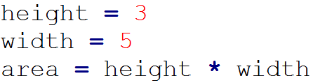

* Amend this code to:
  + output the result of the calculation
  + include a variable for the depth of the shape
  + calculate the volume of the shape (area * depth)

Note: volume = height × width × depth.

……………………………………………………………………………………………….................

……………………………………………………………………………………………….................

……………………………………………………………………………………………….................

……………………………………………………………………………………………….................

……………………………………………………………………………………………….................

……………………………………………………………………………………………….................

……………………………………………………………………………………………….................

……………………………………………………………………………………………….................

……………………………………………………………………………………………….................

……………………………………………………………………………………………….................